UNIVERSITY OF INFORMATION TECHNOLOGY
FACULTY OF INFORMATION SYSTEMS
WEB APPLICATION DEVELOPMENT
LAB 1 PRACTICAL REPORT
Modern Web Foundations & AI-Assisted Engineering
Architectural Thinking • Rigorous Verification • WCAG 2.2 A11y • Resilient Web APIs
Student | Nguyen Ha Linh
Student ID | 242520963
Instructor | MSc. Tran Vinh Khiem
Academic Year | 2025 - 2026

Submission Structure
This report is organized around the three Lab 1 exercises. Each exercise records the Git/web/Markdown evidence, AI-agent evidence, and result screenshots required for submission.

Exercise 1 - Semantic DOM Architecture & A11y Contract
Objective: Build an HTML5 semantic landmark tree with an accessibility contract. The exercise requires Task T-01 to be declared before coding or prompting AI, a 0-<div> semantic structure, a single <h1>, an accessible skip-link, Chrome DevTools verification, and an atomic Git commit.

1.1 Git / Web / Markdown
Git / Web / Markdown link | [Paste repository, deployed web page, or relevant .md link here]  Lab 1 - Web Application Development 2026/index.html
AI agent link | [Paste AI-agent / conversation / shared workspace link here]  [Gemini Notebook]  [ChatGPT]
Result screenshots | [Insert screenshots below this section]

1.2 AI Agent
AI workflow evidence: show the isolated prompt used for Task T-01 and the resulting code review. The lab emphasizes decomposition before prompting and verification after generation.
[Paste AI-agent link here]

1.3 Result Screenshots
Screenshot 1 - Semantic HTML / rendered page
[Insert screenshot here]
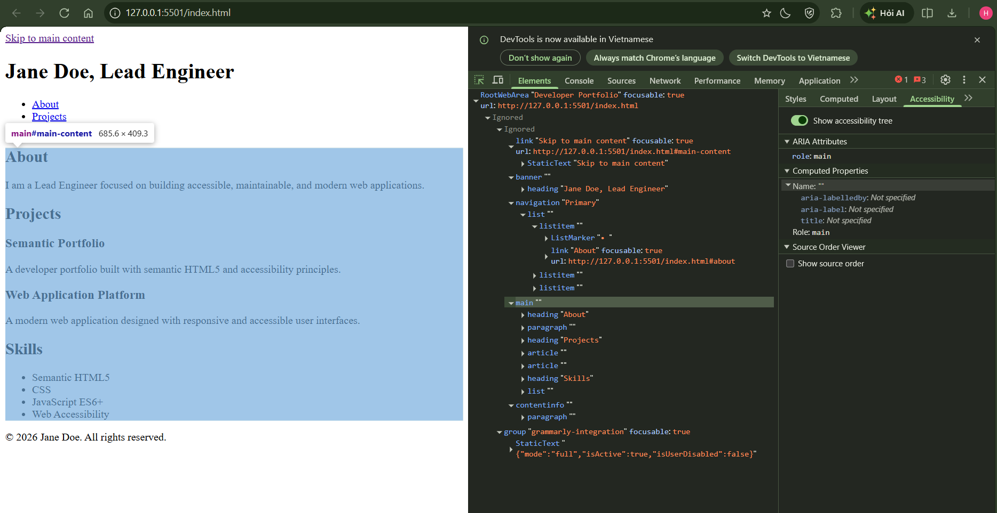
Screenshot 2 - Chrome DevTools Accessibility → Landmark Tree
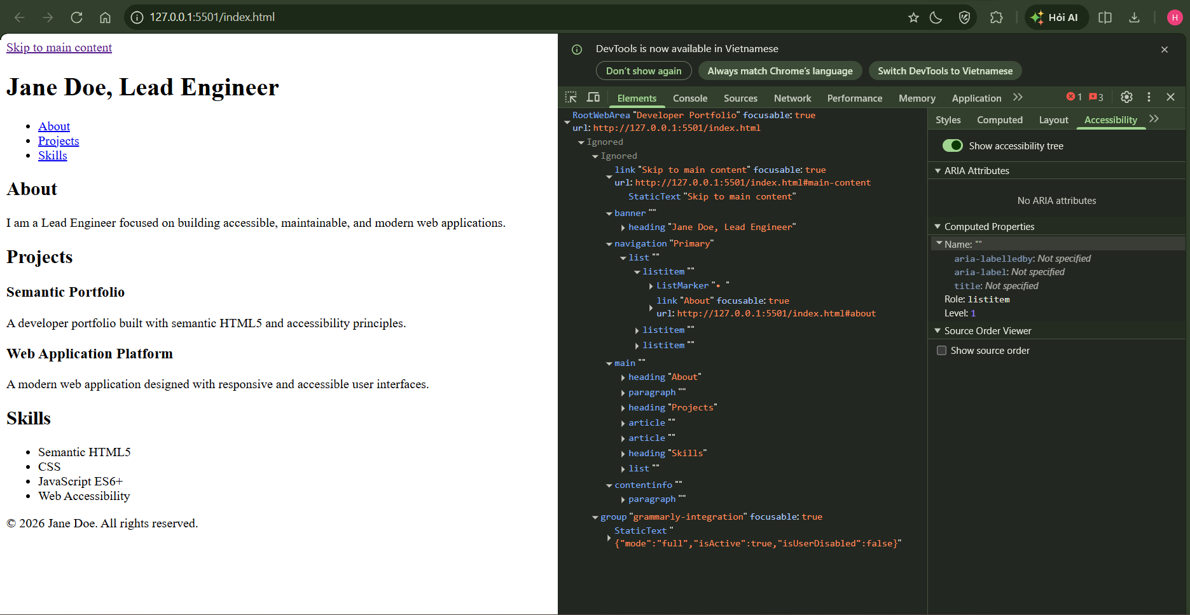
Screenshot 3 - Git diff / atomic commit
[Insert screenshot here]
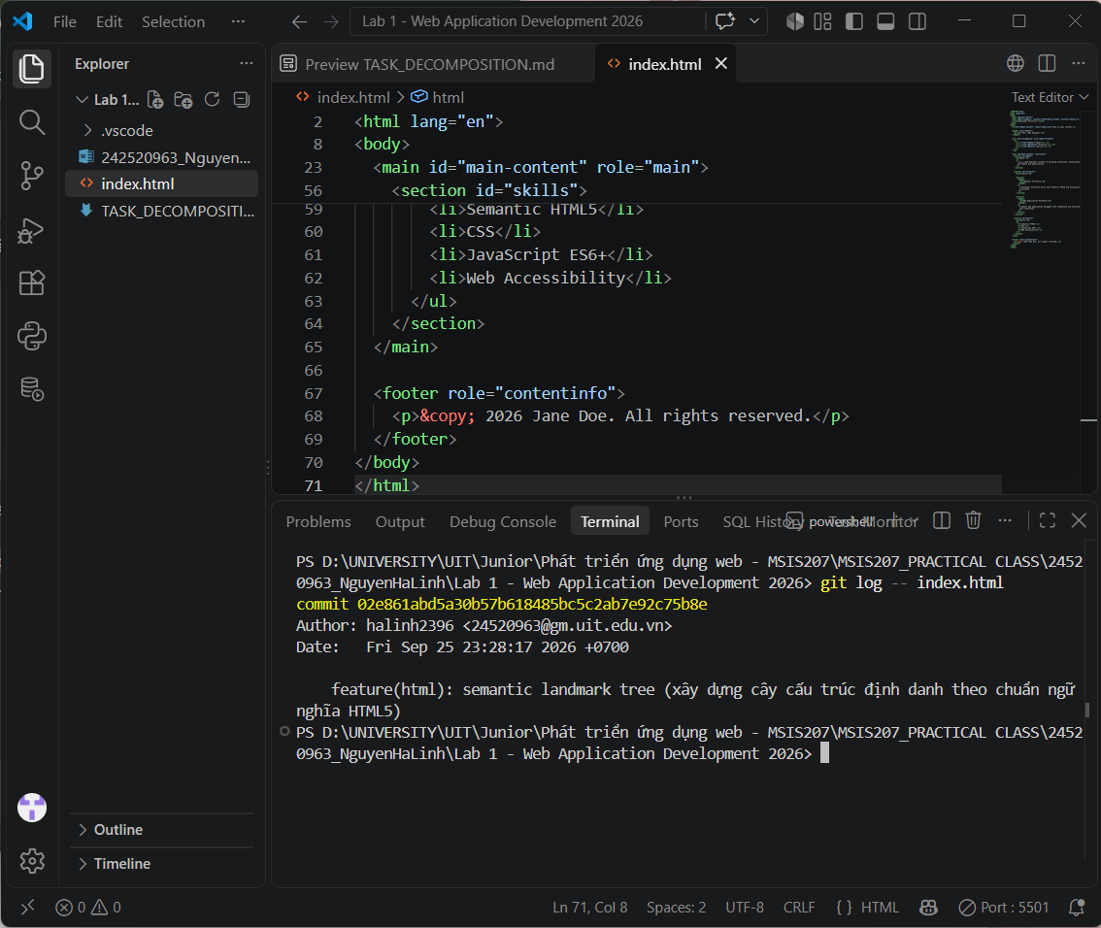

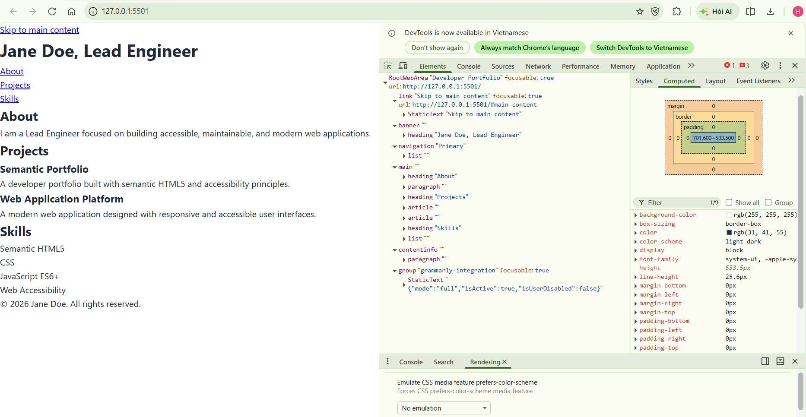
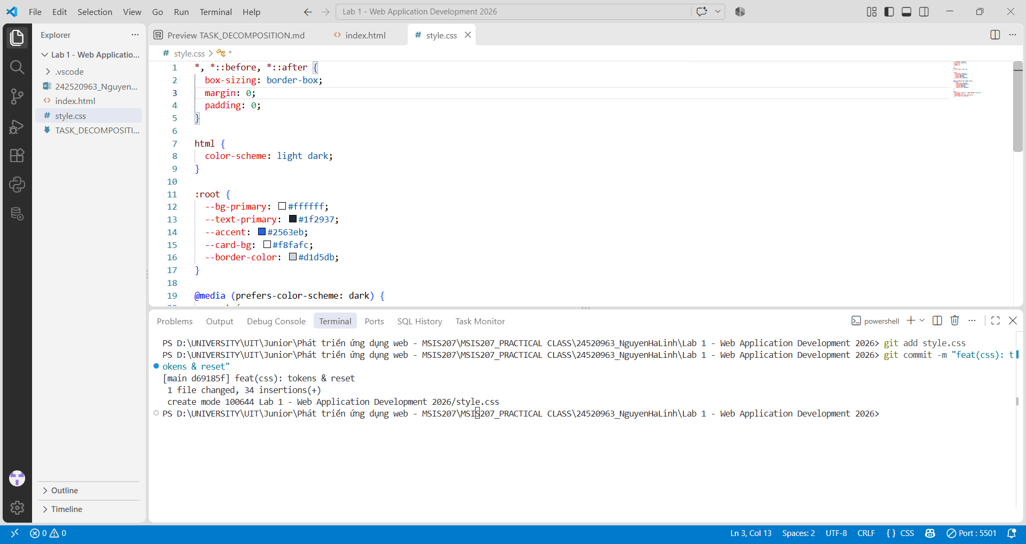

Exercise 2 - Enterprise Developer Portfolio
Objective: Develop a responsive portfolio through decomposed CSS and JavaScript milestones. The required architecture includes design tokens and reset, a responsive 2D Grid layout, an accessible theme switcher, and contract-first state persistence using localStorage key 'theme'. Acceptance criteria include 375px responsiveness, WCAG 2.2 AA contrast, keyboard navigation, and zero console errors during theme toggling.

2.1 Git / Web / Markdown
Git / Web / Markdown link | [Paste repository, deployed web page, or relevant .md link here]
AI agent link | [Paste AI-agent / conversation / shared workspace link here]
Result screenshots | [Insert screenshots below this section]

2.2 AI Agent
AI workflow evidence should show the separate prompts/milestones rather than a monolithic request. The report should include the agent link used to generate or review the implementation.
[Paste AI-agent link here]

2.3 Result Screenshots
Screenshot 1 - Portfolio desktop view
[Insert screenshot here]
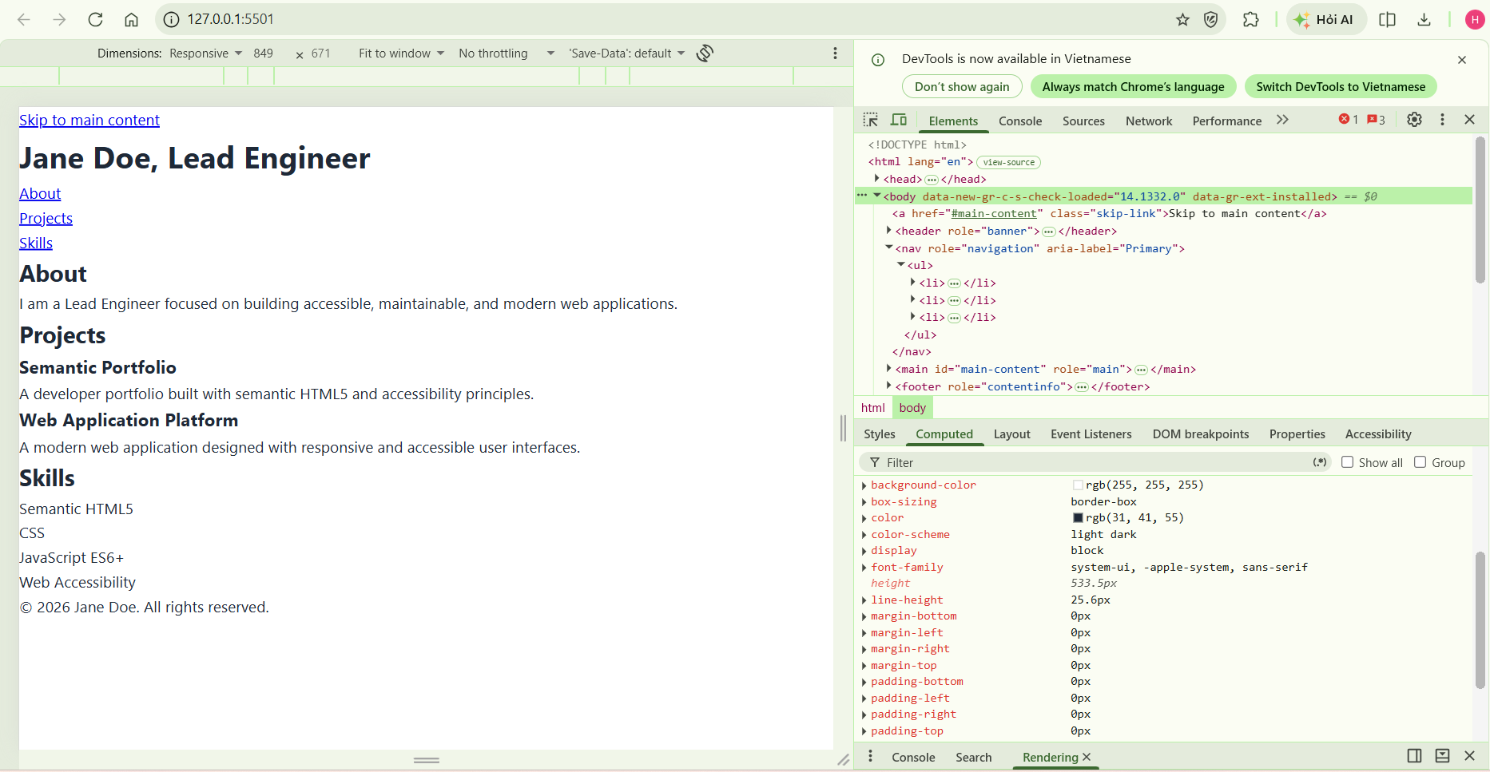
Screenshot 2 - 375px mobile/responsive view
[Insert screenshot here]
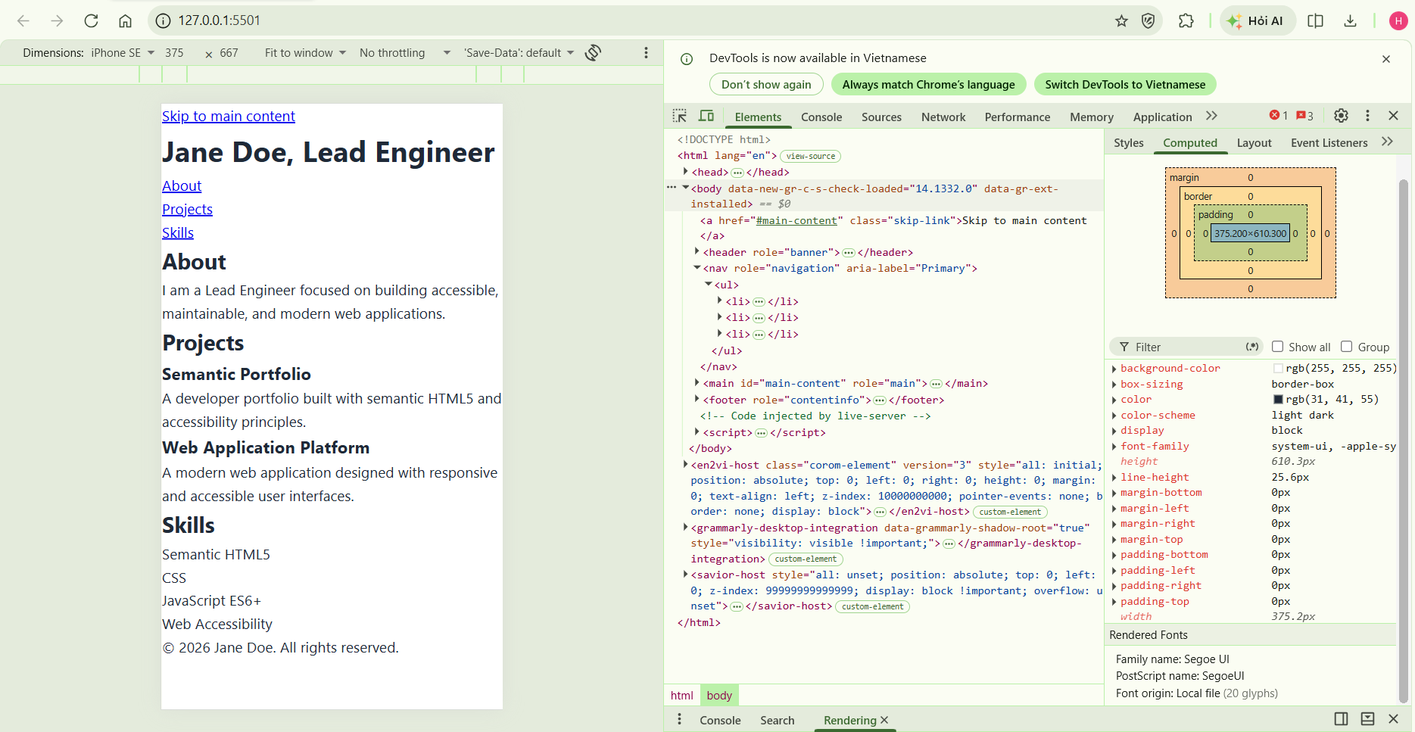
Screenshot 3 - Dark/light theme toggle and keyboard navigation
[Insert screenshot here]
Screenshot 4 - DevTools console / verification evidence
[Insert screenshot here]
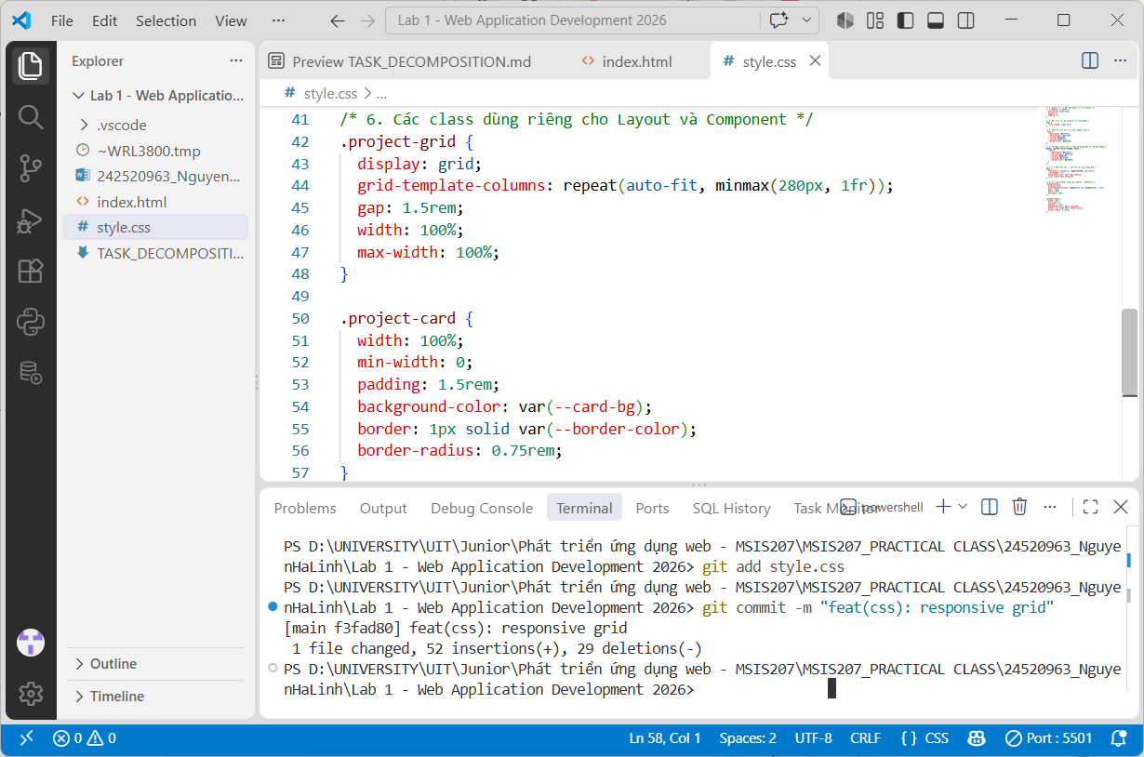

Exercise 3 - Resilient Component Architecture
Objective: Implement a resilient component using a four-state contract: Loading Skeleton, Live Data, Empty, and Error. The exercise requires a state machine to be defined before prompting AI, individual commits for the states, and an accessible retry trigger for error handling.

3.1 Git / Web / Markdown
Git / Web / Markdown link | [Paste repository, deployed web page, or relevant .md link here]
AI agent link | [Paste AI-agent / conversation / shared workspace link here]
Result screenshots | [Insert screenshots below this section]

3.2 AI Agent
AI workflow evidence should demonstrate isolated generation and verification of each component state. The final implementation should be checked against the state contract and resilient UI behavior.
[Paste AI-agent link here]

3.3 Result Screenshots
Screenshot 1 - Loading / skeleton state
[Insert screenshot here]
Screenshot 2 - Live data state
[Insert screenshot here]
Screenshot 3 - Empty state
[Insert screenshot here]
Screenshot 4 - Error state with accessible retry trigger
[Insert screenshot here]

Verification Summary
- Functional: verify the implementation against the stated acceptance criteria.
- Responsive: verify the layout at the 375px mobile baseline and check for horizontal scrolling.
- Accessibility: verify keyboard navigation and semantic landmarks; use the relevant WCAG 2.2 A11y checks.
- Performance: inspect Core Web Vitals, especially LCP, INP, and CLS where applicable.
- Security: avoid rendering unescaped user input with innerHTML.
- AI verification: inspect Git diff, test generated code, and keep atomic commits as evidence of decomposition.

References to Lab Materials
The report structure and exercise requirements are based on the provided Lab 1 materials. The main lab deck identifies the three hands-on exercises and their submission/verification requirements; the Exercise 1 notes provide the detailed Semantic DOM and A11y contract.

